Port Forwarder Testing Document
Ben Soer
A00843110
Eric Tsang
A00841554

Table of Contents
Summary 4
Results 7
TCP_T1 7
Client 7
Port Forwarder 7
Server 7
UDP_T1 8
Client 8
Port Forwarder 8
Server 8
UDP_T2 9
Client 9
Port Forwarder 9
Server 9
SSH_T1 10
Client 10
Mapping 10
Port Forwarder 10
SSH_T2 10
Client 10
Mapping 11
Port Forwarder 11
HTTP_T1 12
Client 12
Mapping 12
Port Forwarder 12
HTTP_T2 13
Client 13
Mapping 13
Port Forwarder 13
TELNET_T1 14
Client 14
Mapping 14
Port Forwarder 14
TELNET_T2 15
Client 15
Mapping 15
Port Forwarder 15
SSL_T1 16
Client 16
Mapping 16
Port Forwarder 17
17
SSL_T2 17
Client 17
Mapping 18
Port Forwarder 18
SFTP_T1 19
Client 19
Mapping 19
Port Forwarder 19
SFTP_T2 20
Client 20
Mapping 20
Port Forwarder 21
GUI_T1 21
GUI 21
Mapping 22
Port Forwarder 22
GUI_T2 23
GUI 23
Mapping 23
Port Forwarder 23
GUI_T3 24
GUI 24
Mapping 24
Server 24
Hping3 24
GUI_T4 25
GUI 25
Mapping 25
Server 25
Hping3 26
GUI_T5 27
GUI 27
Mapping 27
Server 27
Hping3 27
GUI_T6 29
GUI 29
Mapping 29
Server 29
Hping3 29

Summary
Test # | Test Procedure | Parameters | Expected Outcome | Actual Outcome | Pass / Fail
TCP_T1 | Send data back and forth through port forwarder | “Hello” from Client to Server. “Hello Back” from Server to Client | Message Sends and Transfers Successfully | Message Sends and Transfers Successfully | Pass
UDP_T1 | Send data back and forth through port forwarder. Creates new record | “Hello” from Client to Server. “Hello Back” from Server to Client | Message Sends and Transfers Successfully | Message Sends and Transfers Successfully | Pass
UDP_T2 | Send data back and forth through port forwarder with existing record | “Hello” from Client to Server. “Hello Back” from Server to Client | Message Sends and Transfers Successfully | Message Sends and Transfers Successfully | Pass
SSH_T1 | Connect to SSH server through port forwarder | N/A | Connection Establishes, functions and disconnects successfully | Connection Establishes, functions and disconnects successfully | Pass
SSH_T2 | Connect to non-existent SSH server through port forwarder | N/A | Connection fails to connect. User gets prompt of failed connection. Server Resets | Connection fails to connect. User gets prompt of failed connection. Server Resets | Pass
HTTP_T1 | Connect to HTTP server through port forwarder | N/A | Connection Establishes, functions and disconnects successfully | Connection Establishes, functions and disconnects successfully | Pass
HTTP_T2 | Connect to non-existent HTTP server through port forwarder | N/A | Connection fails to connect. User gets prompt of failed connection. Server Resets | Connection fails to connect. User gets prompt of failed connection. Server Resets | Pass
TELNET_T1 | Connect to Telnet server through port forwarder | N/A | Connection Establishes, functions and disconnects successfully | Connection Establishes, functions and disconnects successfully | Pass
TELNET_T2 | Connect to non-existent Telnet server through port forwarder | N/A | Connection fails to connect. User gets prompt of failed connection. Server Resets | Connection fails to connect. User gets prompt of failed connection. Server Resets | Pass
SSL_T1 | Connect to SSL server through port forwarder | N/A | Connection Establishes, functions and disconnects successfully | Connection Establishes, functions and disconnects successfully | Pass
SSL_T2 | Connect to non-existent SSL server through port forwarder | N/A | Connection fails to connect. User gets prompt of failed connection. Server Resets | Connection fails to connect. User gets prompt of failed connection. Server Resets | Pass
SFTP_T1 | Connect to SFTP server through port forwarder | N/A | Connection Establishes, functions and disconnects successfully | Connection Establishes, functions and disconnects successfully | Pass
SFTP_T2 | Connect to non-existent SFTP server through port forwarder | N/A | Connection fails to connect. User gets prompt of failed connection. Server Resets | Connection fails to connect. User gets prompt of failed connection. Server Resets | Pass
GUI_T1 | Load with Mappings in DB | N/A | GUI Loads in Mappings as existing mappings | GUI Loads in Mappings as existing mappings | Pass
GUI_T2 | Load with no Mappings in DB | N/A | GUI Loads and does no load any mappings as none exist | GUI Loads and does no load any mappings as none exist | Pass
GUI_T3 | Create a UDP Mapping | N/A | UDP Mapping is Created and Connections can connect to new port | UDP Mapping is Created and Connections can connect to new port | Pass
GUI_T4 | Create a TCP Mapping | N/A | TCP Mapping is Created and Connections can connect to new port | TCP Mapping is Created and Connections can connect to new port | Pass
GUI_T5 | Delete a UDP Mapping | N/A | UDP Mapping is Deleted and Connections cannot connect to the old port | UDP Mapping is Deleted and Connections cannot connect to the old port | Pass
GUI_T6 | Delete a TCP Mapping | N/A | TCP Mapping is Deleted and Connections cannot connect to the old port | TCP Mapping is Deleted and Connections cannot connect to the old port | Pass

Results
All original images can be found in the /doc/tests folder under their appropriate test# folder name

TCP_T1

Client

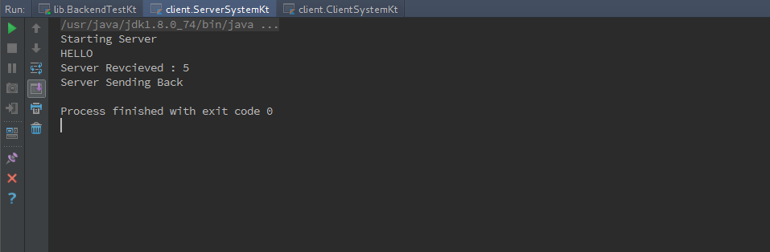
Port Forwarder

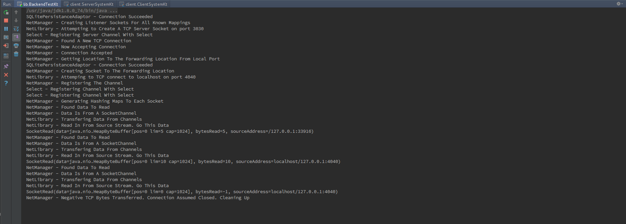
Server
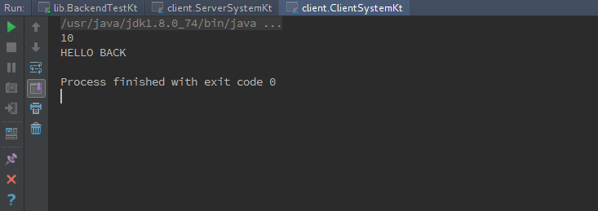

UDP_T1

Client

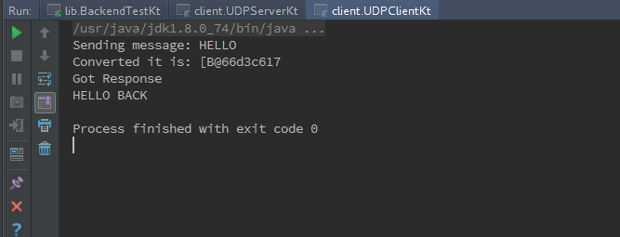
Port Forwarder

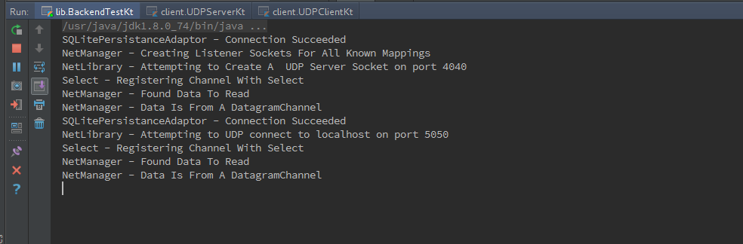
Server
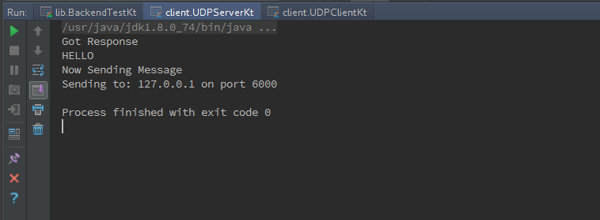

UDP_T2

Client

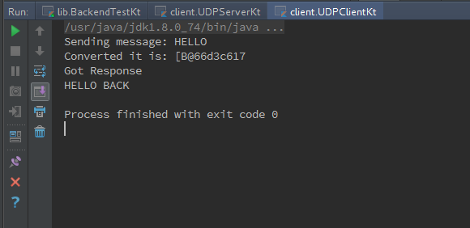
Port Forwarder

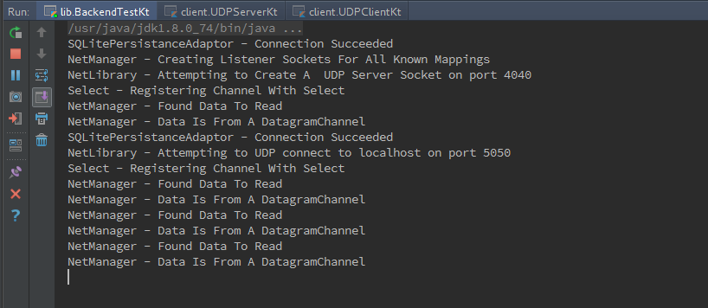
Server
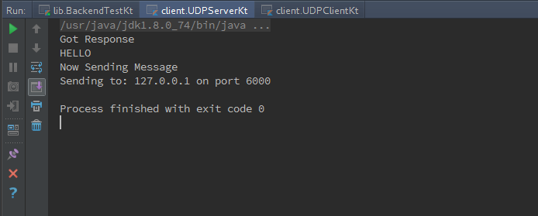

SSH_T1

Client

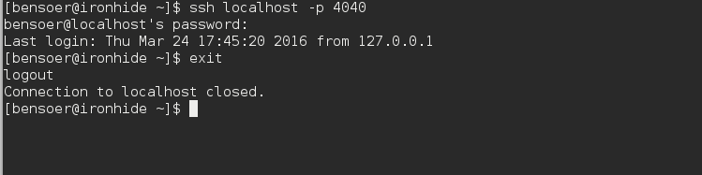
Mapping

Port Forwarder
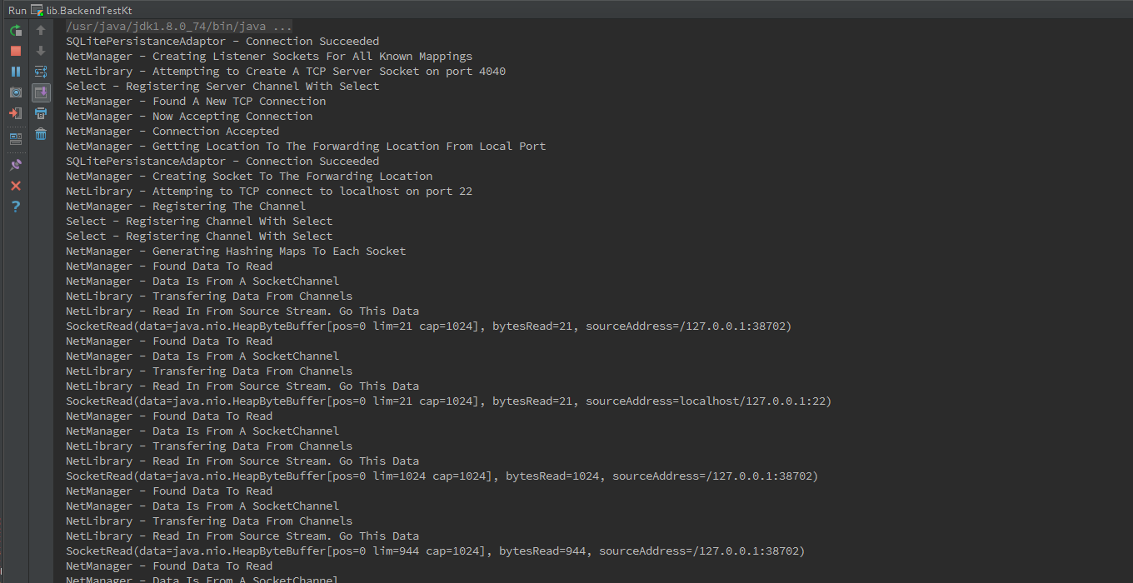

SSH_T2

Client

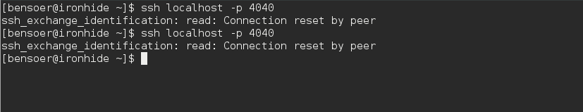
Mapping

Port Forwarder
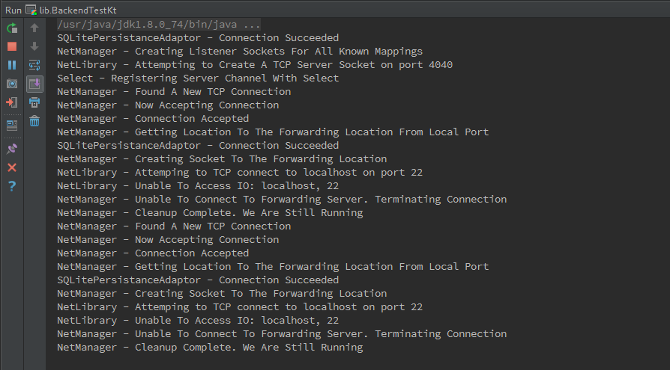

HTTP_T1

Client

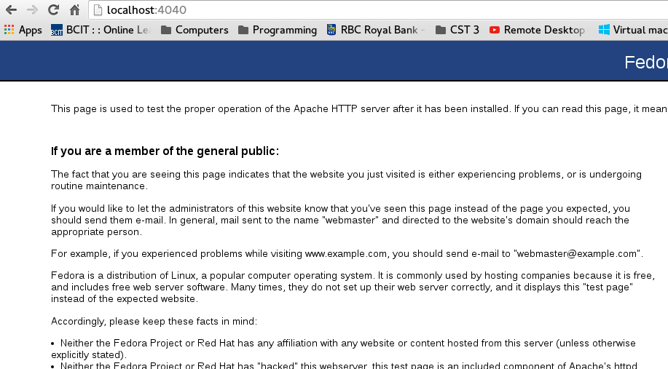
Mapping

Port Forwarder
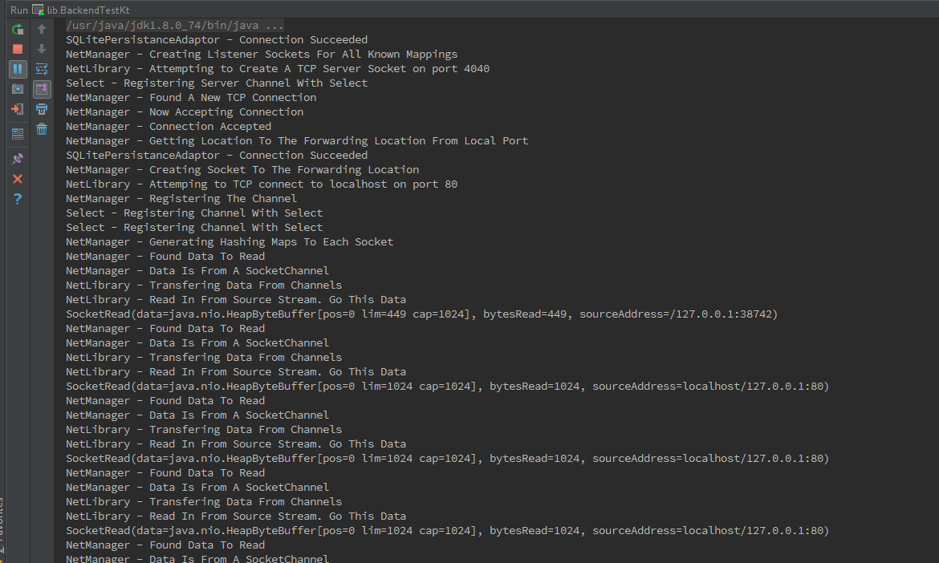

HTTP_T2

Client

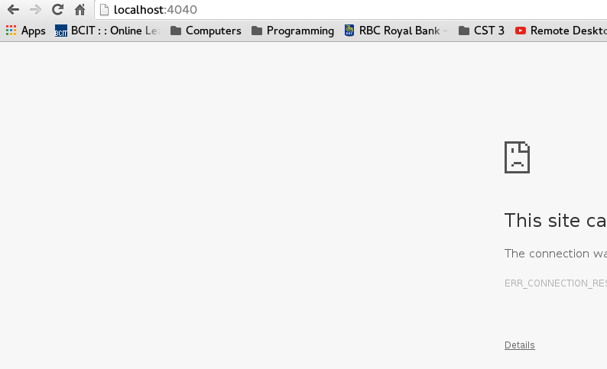
Mapping

Port Forwarder
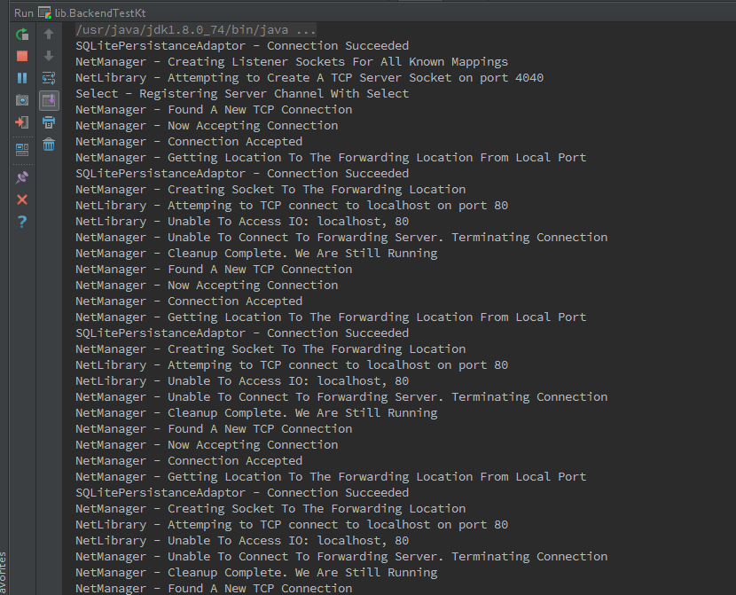

TELNET_T1

Client

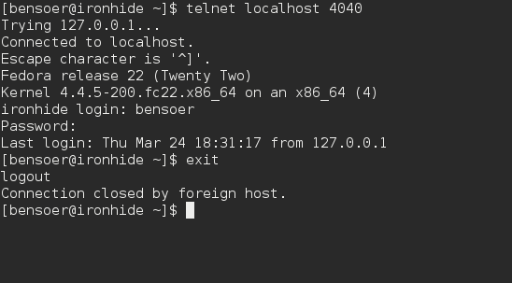
Mapping

Port Forwarder
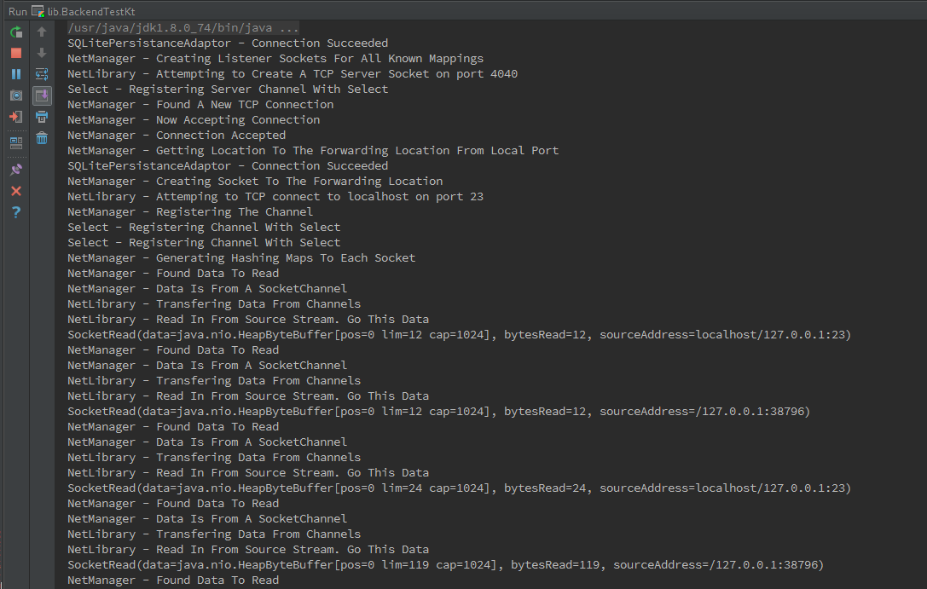

TELNET_T2

Client

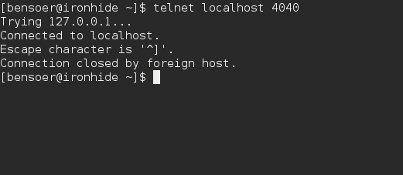
Mapping

Port Forwarder
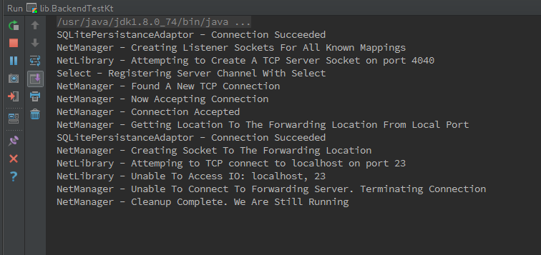

SSL_T1

Client
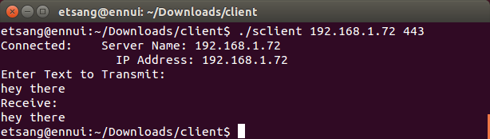

Mapping
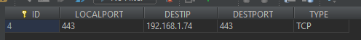

Port Forwarder

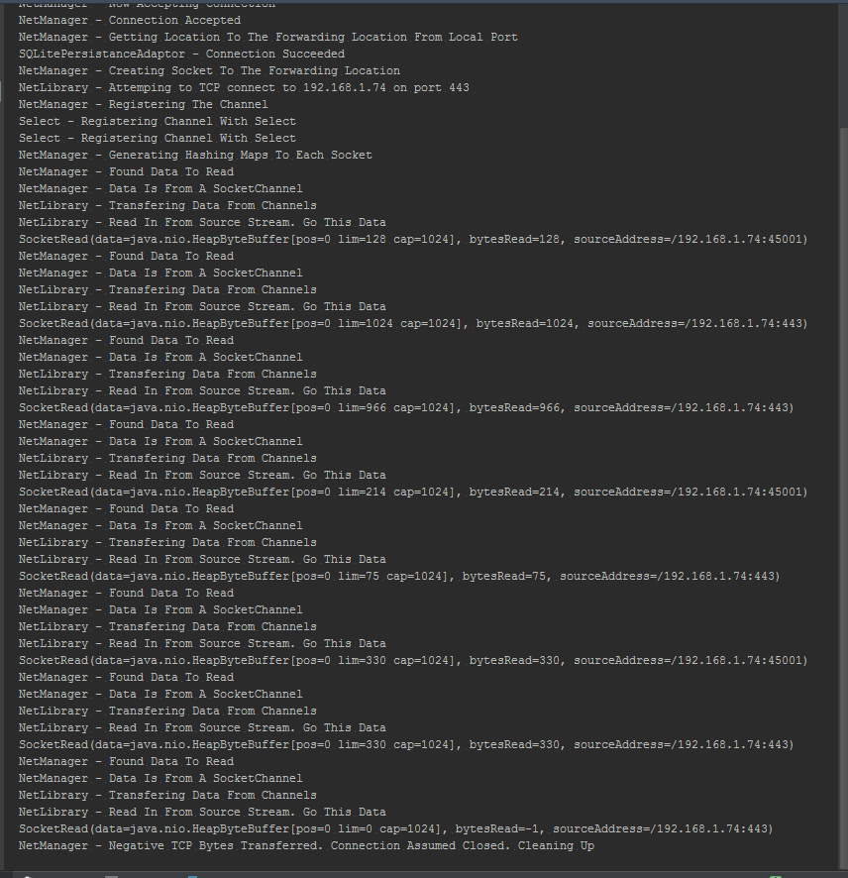

SSL_T2

Client
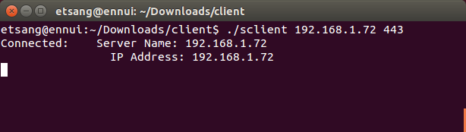

Mapping

Port Forwarder
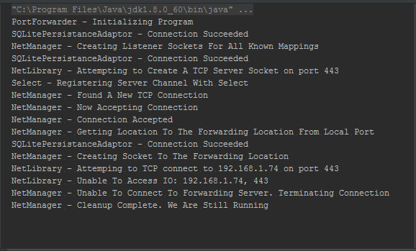

SFTP_T1

Client

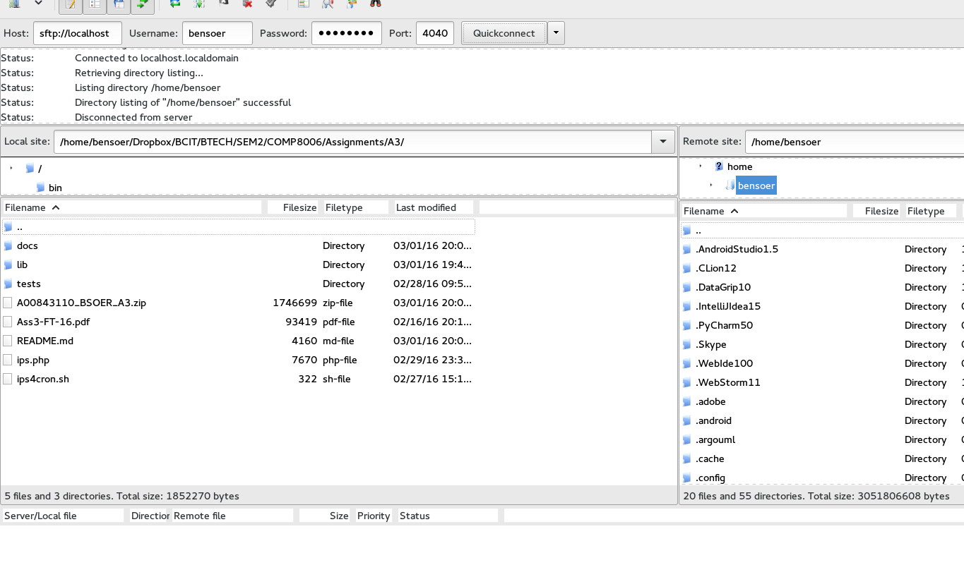
Mapping

Port Forwarder
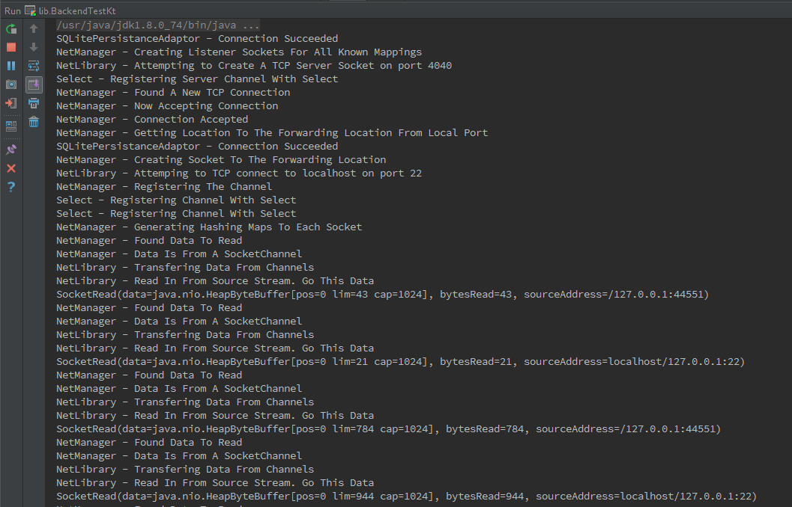

SFTP_T2

Client

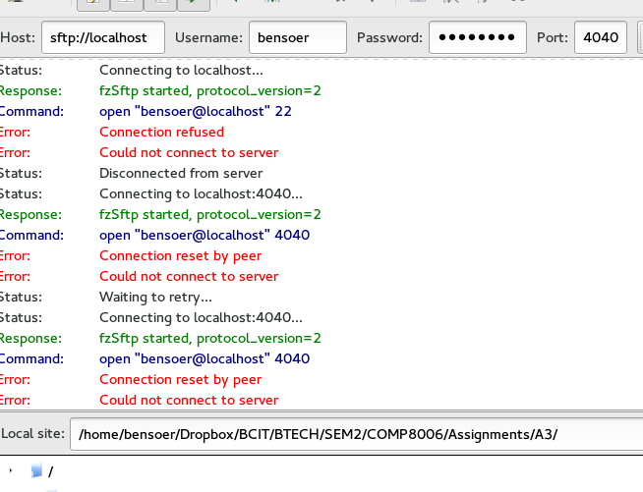
Mapping

Port Forwarder
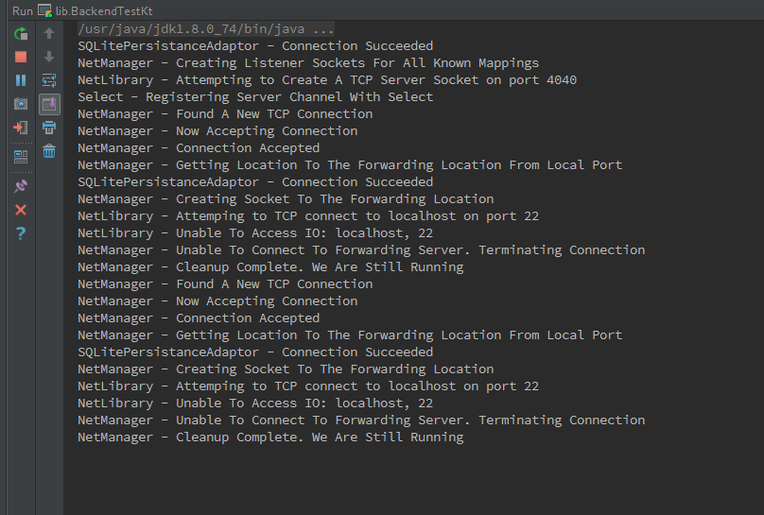

GUI_T1

GUI

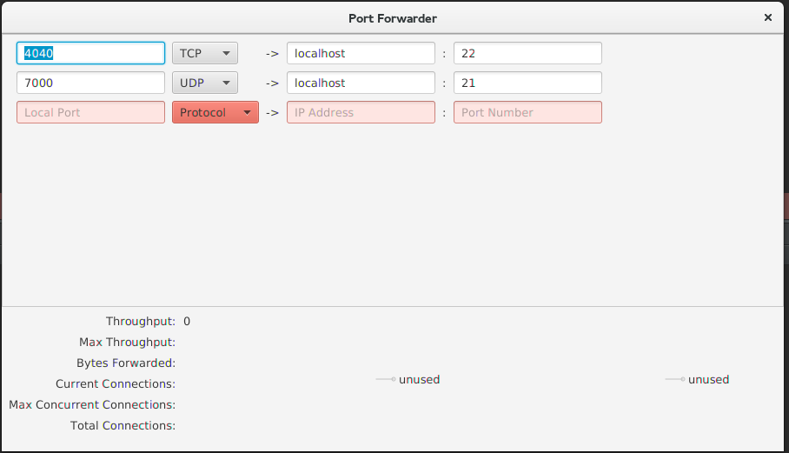
Mapping

Port Forwarder
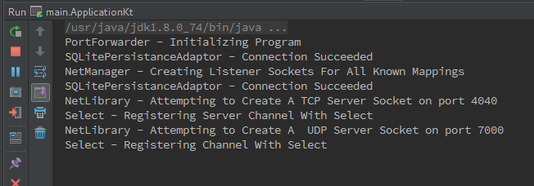

GUI_T2

GUI

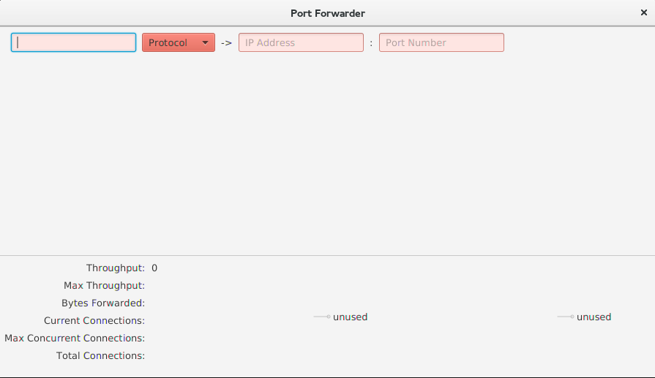
Mapping

Port Forwarder
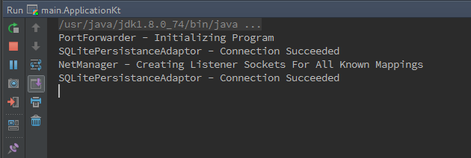

GUI_T3

GUI

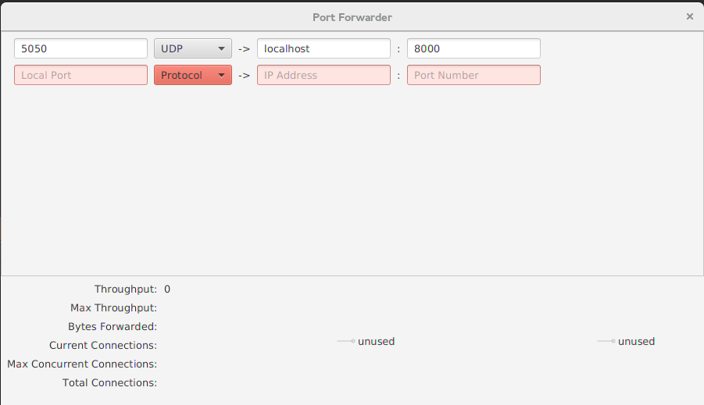
Mapping

Server

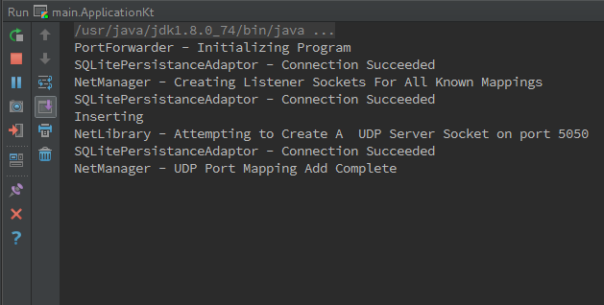
Hping3
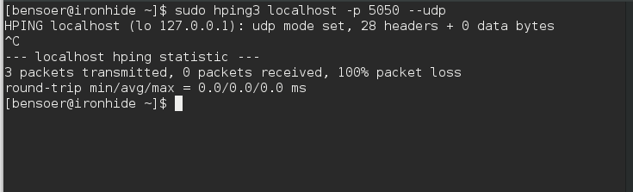

GUI_T4

GUI

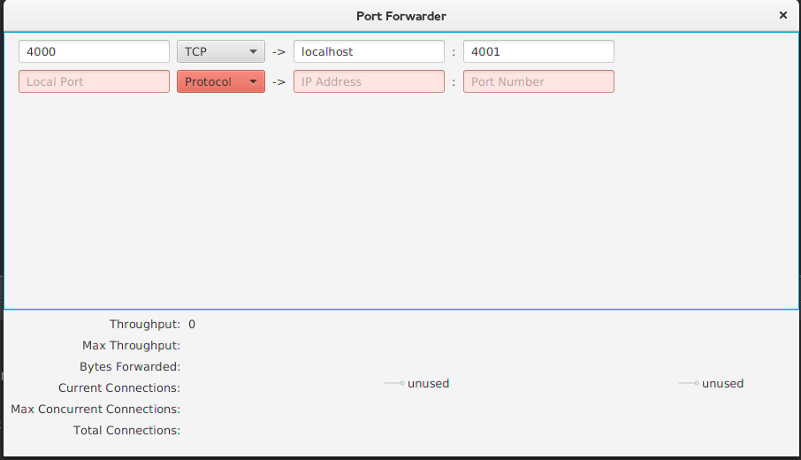
Mapping

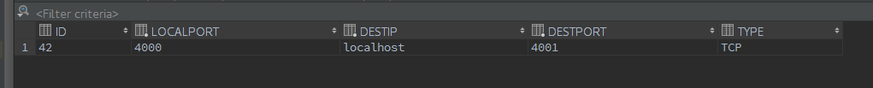
Server

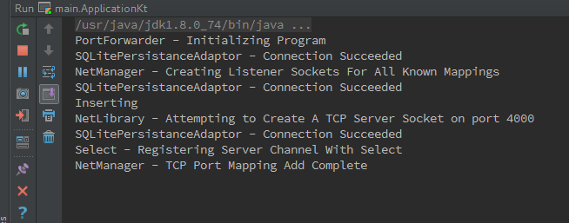
Hping3
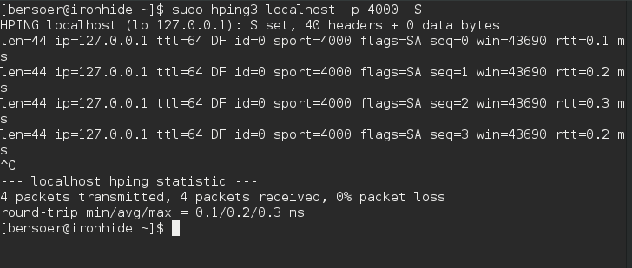

GUI_T5

GUI

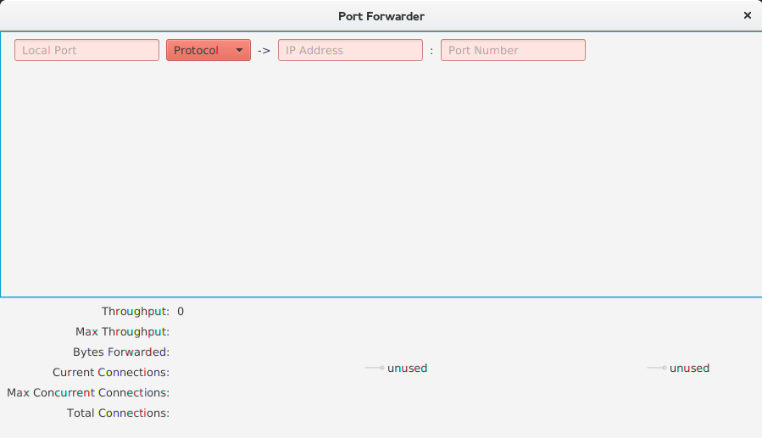
Mapping

Server

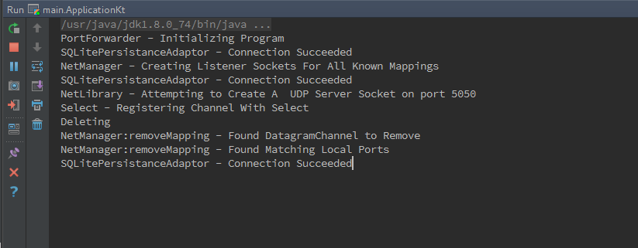
Hping3
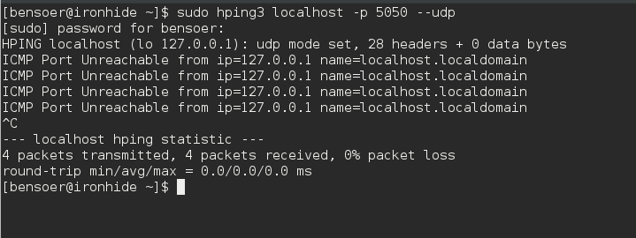

GUI_T6

GUI

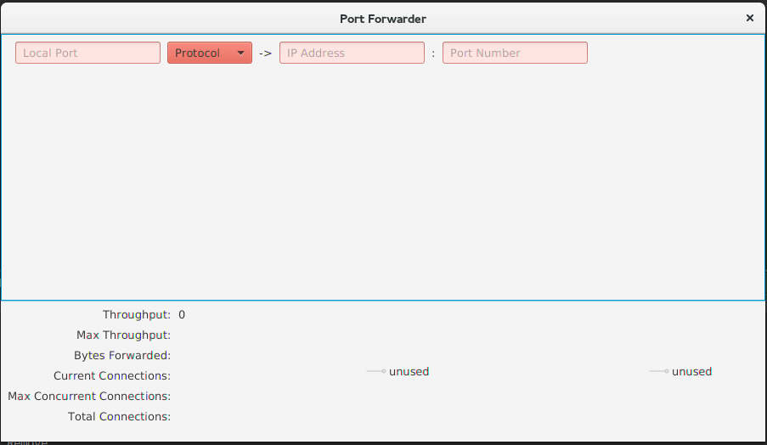
Mapping

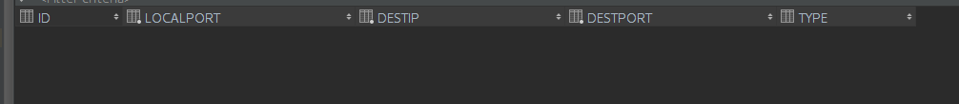
Server

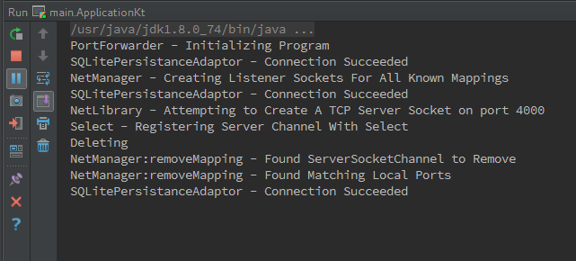
Hping3
